# 5 types of positive message

## Request for information or action

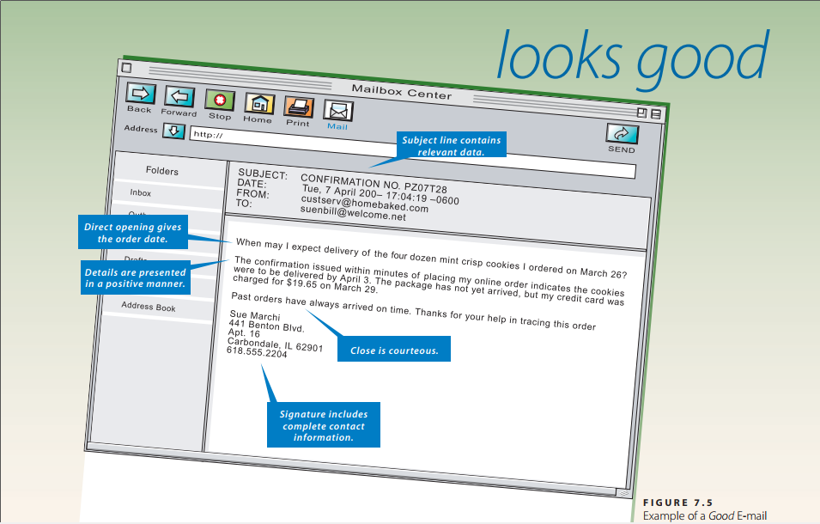

Subject: Confirmation No.PZ07T28

Date: Date + Time

From: [abc@homebaked.com](mailto:abc@homebaked.com)

To: suenbill@welcome.net

When may I expect delivery of the four dozen mini crisp cookies I ordered on March 26?

The confirmation issued within minutes of placing my online order indicates the cookies were to be delivered by April 3. The package has not yet arrived, but my credit card was charged for $19.65 on March 29.

Past orders have always arrived on time. Thanks for your help in tracing this order.

Sue Marchi

441 Benton Bivd,

Apt. 16

Carbondate, IL 62901

618.555.2204

## Request approval letter

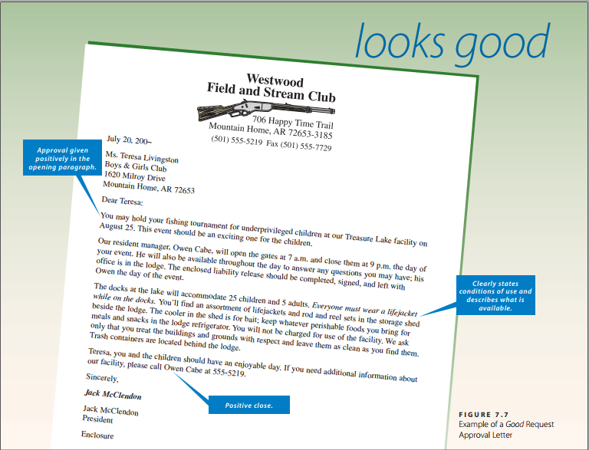

July 20, 200–  
Ms. Teresa Livingston  
Boys & Girls Club  
1620 Milroy Drive  
Mountain Home, AR 72653

Dear Teresa:  
You may hold your fishing tournament for underprivileged children at our Treasure Lake facility on August 25. This event should be an exciting one for the children.  
Our resident manager, Owen Cabe, will open the gates at 7 a.m. and close them at 9 p.m. the day of your event. He will also be available throughout the day to answer any questions you may have; his office is in the lodge. The enclosed liability release should be completed, signed, and left with Owen the day of the event.  
The docks at the lake will accommodate 25 children and 5 adults. *Everyone must wear a lifejacket while on the docks.* You will find an assortment of lifejackets and rod and reel sets in the storage shed beside the lodge. The cooler in the shed is for bait; keep whatever perishable foods you bring for meals and snacks in the lodge refrigerator. You will not be charged for use of the facility. We ask only that you treat the buildings and grounds with respect and leave them as clean as you find them. Trash containers are located behind the lodge.  
Teresa, you and the children should have an enjoyable day. If you need additional information about our facility, please call Owen Cabe at 555-5219.

Sincerely,  
***Jack McClendon***Jack McClendon  
President

Enclosure

## Claim letter

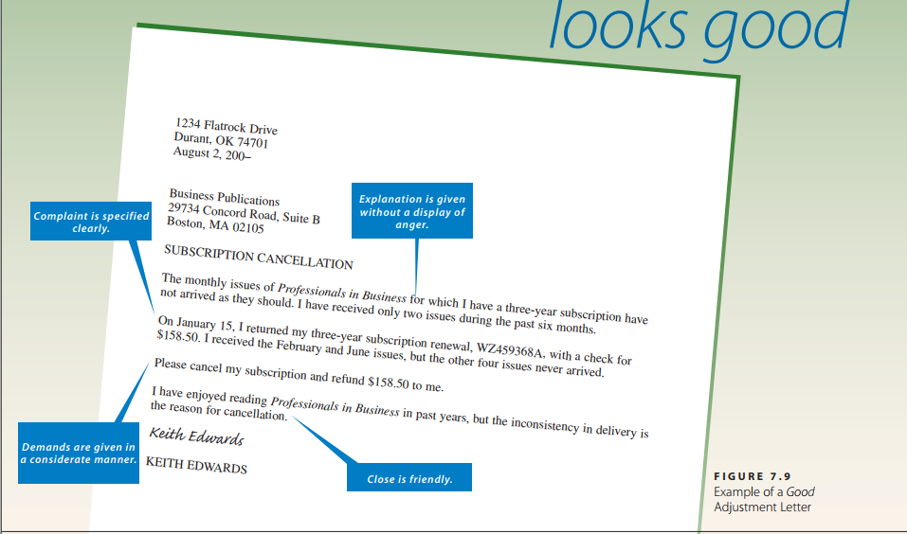

1234 Flatrock Drive  
Durant, OK 74701  
August 2, 200–  
Business Publications  
29734 Concord Road, Suite B  
Boston, MA 02105

SUBSCRIPTION CANCELLATION

The monthly issues of *Professionals in Business* for which I have a three-year subscription have not arrived as they should. I have received only two issues during the past six months.  
On January 15, I returned my three-year subscription renewal, WZ459368A, with a check for $158.50. I received the February and June issues, but the other four issues never arrived.  
Please cancel my subscription and refund $158.50 to me.  
I have enjoyed reading *Professionals in Business* in past years, but the inconsistency in delivery is the reason for cancellation.

*Keith Edwards*KEITH EDWARDS

## Claim adjustment letter

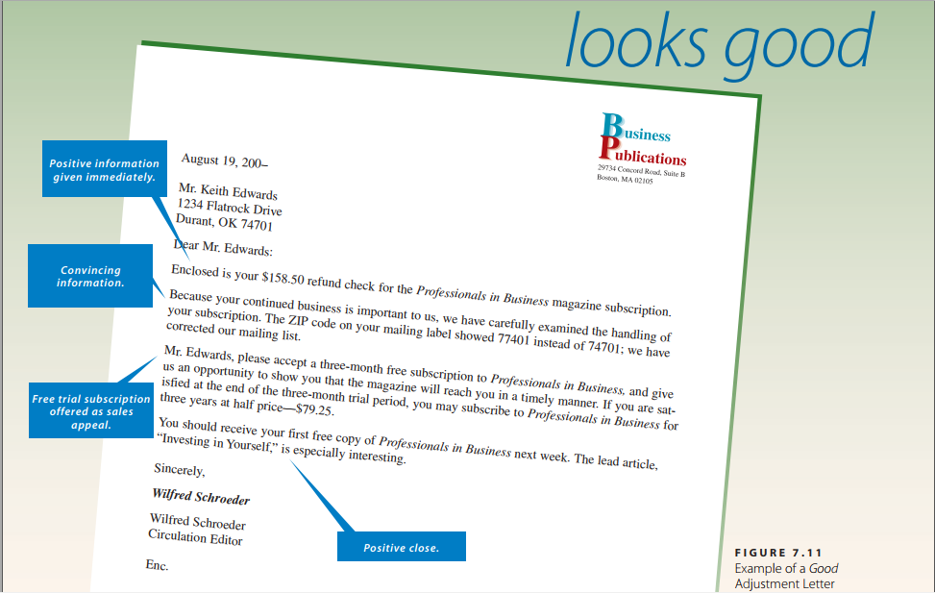

August 19, 200–

Mr. Keith Edwards

1234 Flatrock Drive

Durant, OK 74701

Dear Mr. Edwards:

Enclosed is your $158.50 refund check for the Professionals in Business magazine subscription.

Because your continued business is important to us, we have carefully examined the handling of your subscription. The ZIP code on your mailing label showed 77401 instead of 74701; we have corrected our mailing list.

Mr. Edwards, please accept a three-month free subscription to Professionals in Business, and give us an opportunity to show you that the magazine will reach you in a timely manner. If you are satisfied at the end of the three-month trial period, you may subscribe to Professionals in Business for three years at half price—$79.25.

You should receive your first free copy of Professionals in Business next week. The lead article, “Investing in Yourself,” is especially interesting.

Sincerely,

Wilfred Schroeder

Wilfred Schroeder

Circulation Editor

## Social business message

### Congratulations

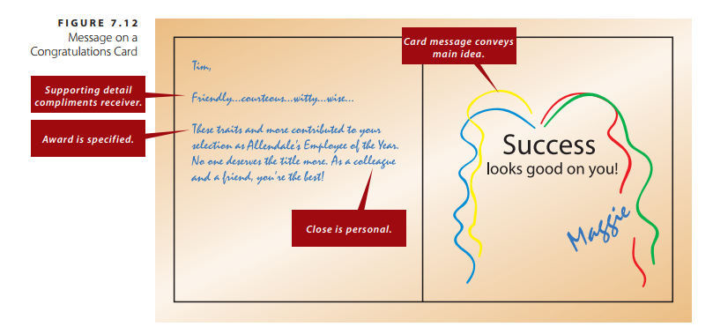

### Condolence

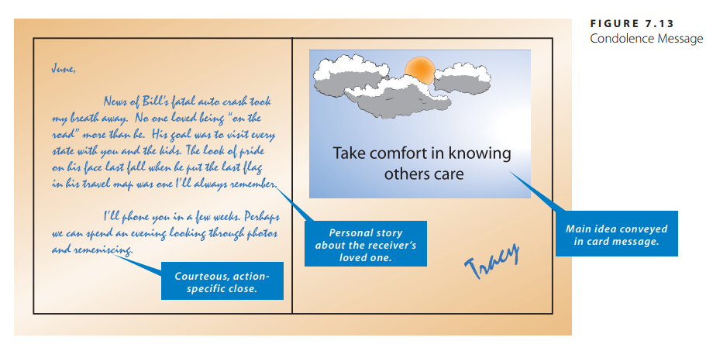

### Appreciation

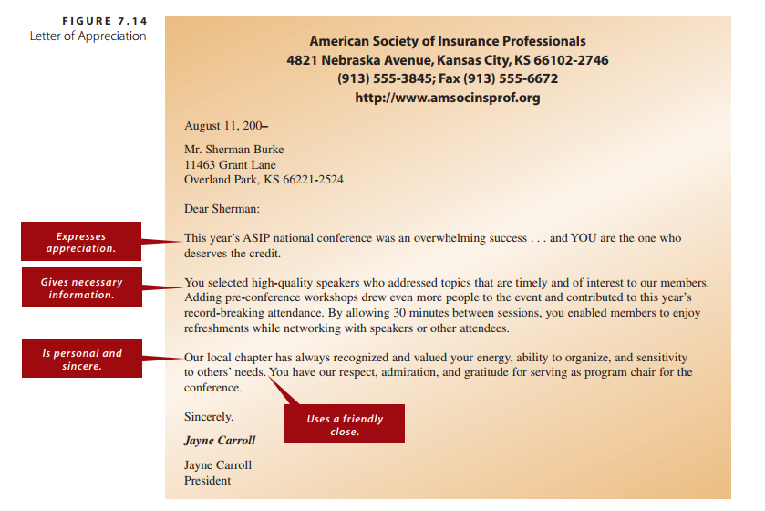

Mr. Sherman Burke  
11463 Grant Lane  
Overland Park, KS 66221-2524

Dear Sherman:  
This year’s ASIP national conference was an overwhelming success . . . and YOU are the one who deserves the credit.  
You selected high-quality speakers who addressed topics that are timely and of interest to our members.  
Adding pre-conference workshops drew even more people to the event and contributed to this year’s record-breaking attendance. By allowing 30 minutes between sessions, you enabled members to enjoy refreshments while networking with speakers or other attendees.  
Our local chapter has always recognized and valued your energy, ability to organize, and sensitivity to others’ needs. You have our respect, admiration, and gratitude for serving as program chair for the conference.

Sincerely,  
Jayne Carroll  
President

### Invitation

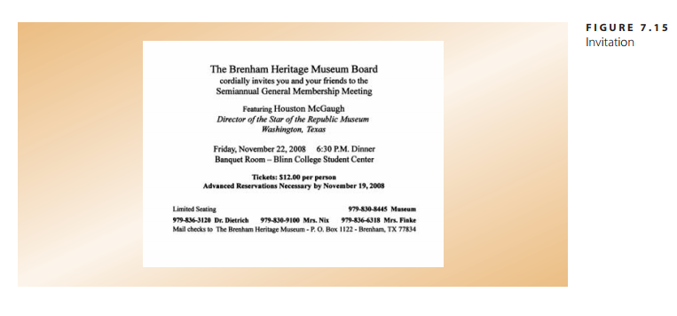

### Holiday greeting



### Welcome

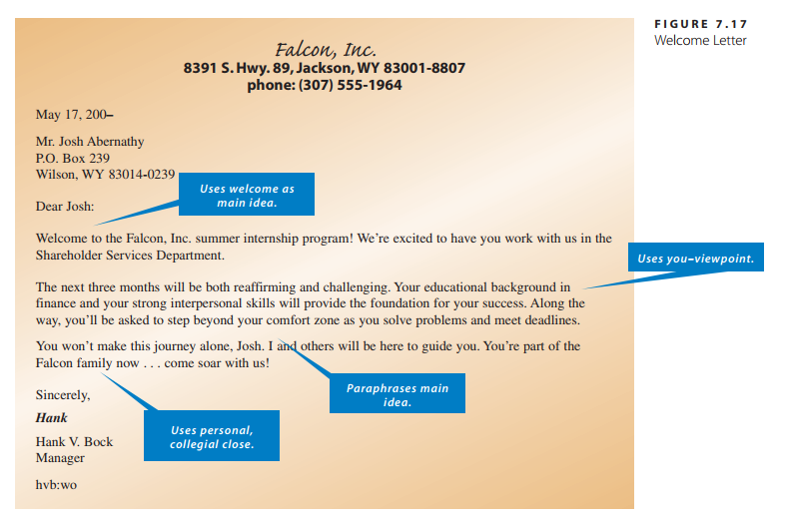

*Falcon, Inc.* Welcome Letter  
**8391 S. Hwy. 89, Jackson, WY 83001-8807  
phone: (307) 555-1964**May 17, 200–  
Mr. Josh Abernathy  
P.O. Box 239  
Wilson, WY 83014-0239

Dear Josh:  
Welcome to the Falcon, Inc. summer internship program! We’re excited to have you work with us in the Shareholder Services Department.  
The next three months will be both reaffirming and challenging. Your educational background in finance and your strong interpersonal skills will provide the foundation for your success. Along the way, you’ll be asked to step beyond your comfort zone as you solve problems and meet deadlines.  
You won’t make this journey alone, Josh. I and others will be here to guide you. You’re part of the Falcon family now . . . come soar with us!

Sincerely,  
***Hank***Hank V. Bock  
Manager